Setting up Unity projects
- Edit->Project Settings ->Editor
- Set Serialization to Force Text

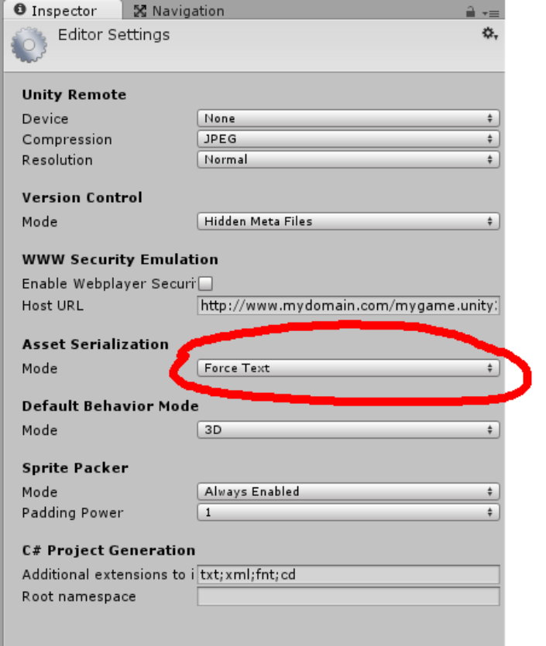
This makes Unity scene files save as text files, and allows us to visually diff them when conflicts arise.
They're still not entirely human readable, but better than binary files.

The Team Leader needs to do this once, and the setting will carry over into all user's projects.

Adding your existing project to Github (Team Source Control Leader)

- Go to the Github website and log in.
- Create a new Repository and name it sensibly.
- Set the .gitignore file to Unity in the droplist.
- Create Repository.
- Copy the repo name from the address bar of your browser.
- Open SourceTree.
- In Explorer rename your project folder (eg stick a “1” on the end.)
- Clone/New.
- Source Path – paste the address from the Browser copied at step 5.
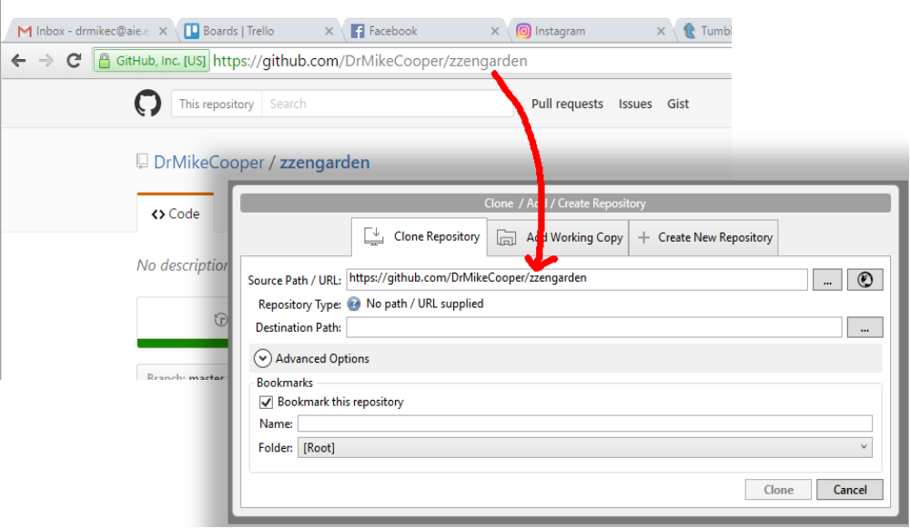
- Destination path – give it the old name of your project folder.
- Press Clone.
- In Explorer, copy your files from the renamed folder to the newly cloned location.
- In Source Tree, tick the “Unstaged Files” checkmark.
- Add a commit message like “Initial Checkin” and Commit.
- Push.

Getting the project out of Source Tree (Team Member)
- Open SourceTree.
- In Explorer rename your project folder (eg stick a “1” on the end.)
- Clone/New.
- Source Path – paste the address from the Browser copied at step 5.
- Destination path – give it the old name of your project folder.
- Press Clone.
- In Explorer, copy your files from the renamed folder to the newly cloned location.
- In Source Tree, tick the “Unstaged Files” checkmark.
- Look at which files have changed before committing and pushing. If in doubt, get help here!

Modifying files in Unity, and WinMerge (Team Member)
What gets changed when you perform certain operations in Unity?
Make a few changes and you can see using WinMerge.

- In SourceTree, go Tools->Options
- Select the Diff tab

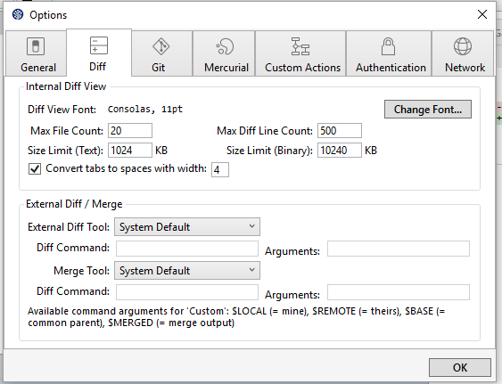
- Under External Diff Tool select WinMerge
- Modify a setting in the local scene by a single numerical parameter, and save.
- Go to SourceTree and notice that the .unity scene file now appears in Unstaged Files

Conflict resolution
This is the worse part of dealing with source control: what happens when two people edit the same file?
Firstly, try not to edit the same file. Do this via communication – figure out who has a particular scene file to work on on any given day.

Going through a conflict. Work through these exercises in pairs.

Easy Merge

User A: Modify a script file by adding the following function before Update():

void FunctionA()
{
}

Commit and Push

User B: Modify the same script by putting this function after Update():

void FunctionB()
{
}

Commit the file.
Pull to get the same file from the server. They should merge easily, since the changes were in separate places in the file.
Commit again, and you'll see an automatic commit message about merging. (Change if you want)
Check the file in Visual Studio, you should see both FunctionA and FunctionB

Push to send the merged file back to the server.

User A : Pull
You should get the merged file now, and see both functions.

Now try an easy merge in a Unity file. Both users modify a single object, and you should be able to commit them and see the two changes happen smoothly.

Hard Merge
User A: Add a function after FunctionB, e.g.

DrMikesChange()
{
}

Commit and Push

User B: Add a different function in the same place! (use your real names, its easier to figure out that way)

DavesChange()
{
}

Commit this change, then Pull.
This will create a conflict because you've both edited the file in the same place.

You'll see something like this in visual Studio:

<<<<<<< HEAD
void DrMikesChange()
=======
void DavesChange()
>>>>>>> 633ec34f28560c1a66be843d2f53f5475581c85e
{
}

For now, manually fix it up to look like this:

void DrMikesChange()
{
}

void DavesChange()
{
}

Back in SourceTree, Right click on the file and select the Resolve Conflict->Mark Resolved
You can now Push the file.

User A:
Pull, and you should see the file with both functions like we fixed it up.

